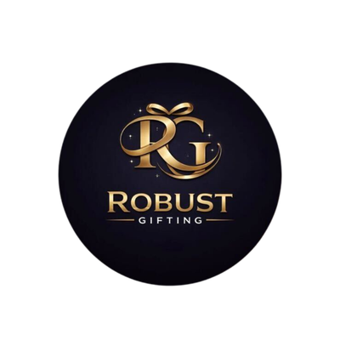
2-in-1 Pen + Keychain Catalogue
Robust Gifting | Premium Corporate Gifting Solutions
44 Premium Designs | Prices exclusive of 18% GST
Item No. 01  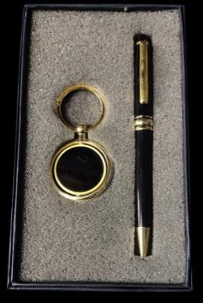  Black roller pen with gold ring keychain  Rs. 106/-  Base Rs. 90 + 18% GST |  | Item No. 02  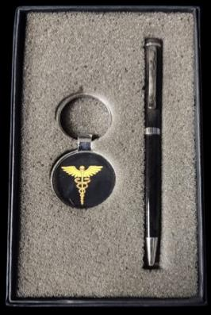  Black pen with gold caduceus emblem keychain  Rs. 153/-  Base Rs. 130 + 18% GST
Item No. 03  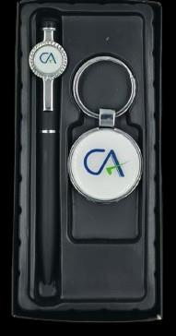  Black pen with CA logo dual-keychain set  Rs. 142/-  Base Rs. 120 + 18% GST |  | Item No. 04  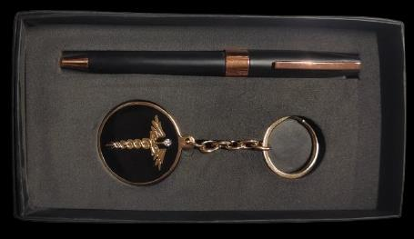  Black & rose-gold pen with caduceus keychain  Rs. 153/-  Base Rs. 130 + 18% GST
Item No. 05  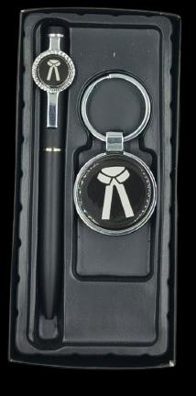  Black pen with circular motif keychain  Rs. 142/-  Base Rs. 120 + 18% GST |  | Item No. 06  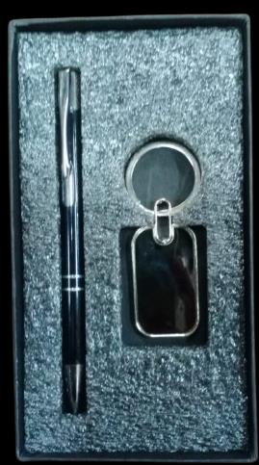  Black pen with square metal keychain  Rs. 77/-  Base Rs. 65 + 18% GST
Item No. 07  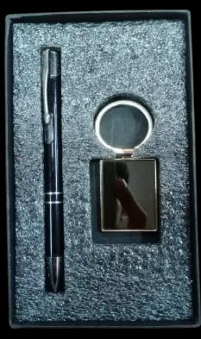  Black pen with square metal keychain, dark finish  Rs. 77/-  Base Rs. 65 + 18% GST |  | Item No. 08  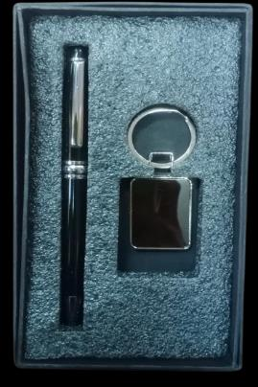  Silver-trim pen with square metal keychain  Rs. 77/-  Base Rs. 65 + 18% GST
Item No. 09  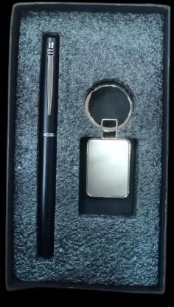  Black pen with rectangular metal keychain  Rs. 83/-  Base Rs. 70 + 18% GST |  | Item No. 10  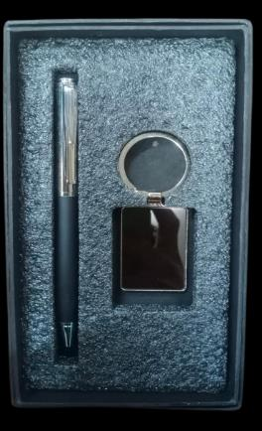  Silver pen with rectangular metal keychain  Rs. 94/-  Base Rs. 80 + 18% GST
Item No. 11    Black pen with rectangular keychain, alt finish  Rs. 83/-  Base Rs. 70 + 18% GST |  | Item No. 12  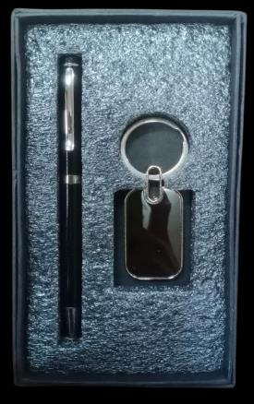  Black pen with square metal keychain, black box  Rs. 83/-  Base Rs. 70 + 18% GST
Item No. 13  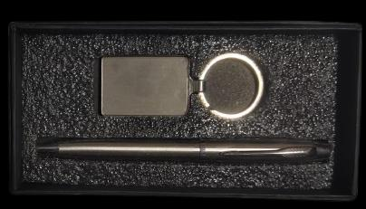  Black pen with oval & rectangular keychain  Rs. 83/-  Base Rs. 70 + 18% GST |  | Item No. 14  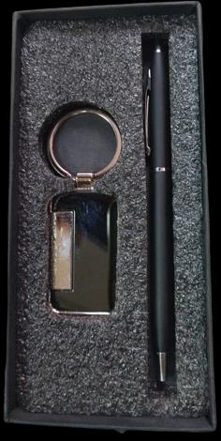  Black pen with gold belt-clip keychain  Rs. 106/-  Base Rs. 90 + 18% GST
Item No. 15  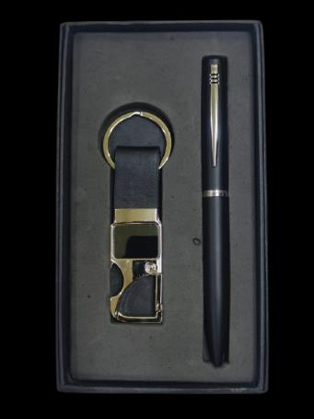  Grey pen with metallic hook keychain  Rs. 106/-  Base Rs. 90 + 18% GST |  | Item No. 17    Black pen with tan leather strap keychain  Rs. 106/-  Base Rs. 90 + 18% GST
Item No. 18  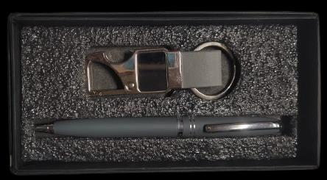  Black pen with tan leather loop keychain  Rs. 94/-  Base Rs. 80 + 18% GST |  | Item No. 19  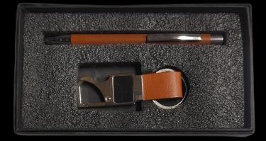  Blue pen with blue leather strap keychain  Rs. 106/-  Base Rs. 90 + 18% GST
Item No. 20  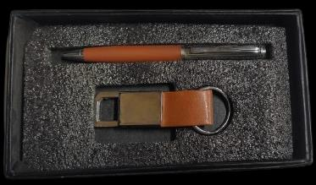  Burgundy pen with red leather keychain  Rs. 94/-  Base Rs. 80 + 18% GST |  | Item No. 21  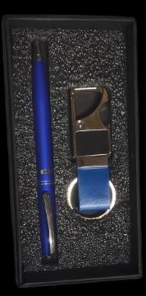  Gold roller pen with gold hook keychain  Rs. 142/-  Base Rs. 120 + 18% GST
Item No. 22  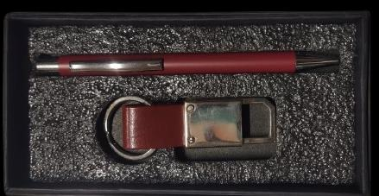  White pen with gold hook keychain  Rs. 106/-  Base Rs. 90 + 18% GST |  | Item No. 23  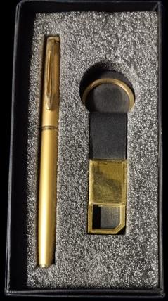  White pen with silver hook keychain  Rs. 106/-  Base Rs. 90 + 18% GST
Item No. 24  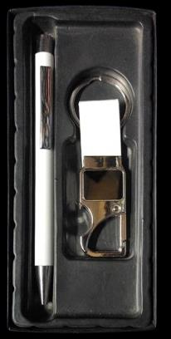  White pen with double-tab silver keychain  Rs. 106/-  Base Rs. 90 + 18% GST |  | Item No. 25  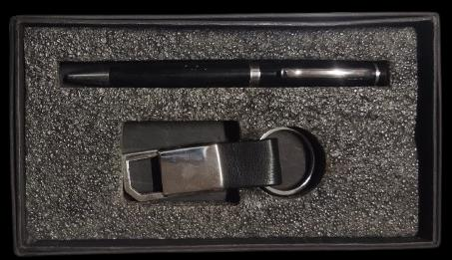  Black pen with ring & tab keychain  Rs. 106/-  Base Rs. 90 + 18% GST
Item No. 26  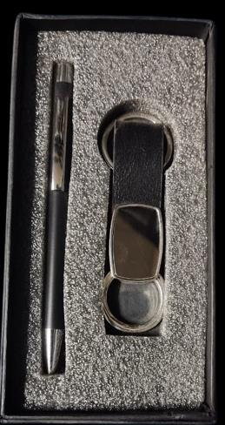  Slim black pen with silver tab keychain  Rs. 106/-  Base Rs. 90 + 18% GST |  | Item No. 27  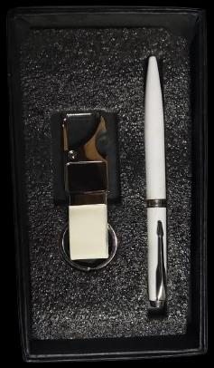  Black pen with double-ring keychain  Rs. 77/-  Base Rs. 65 + 18% GST
Item No. 28  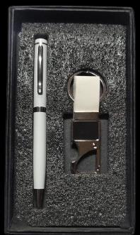  Black pen with leather & metal hook keychain  Rs. 106/-  Base Rs. 90 + 18% GST |  | Item No. 29  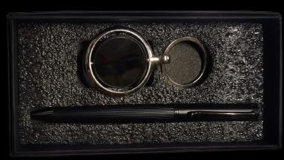  Black roller pen with revolving gold keychain  Rs. 118/-  Base Rs. 100 + 18% GST
Item No. 30  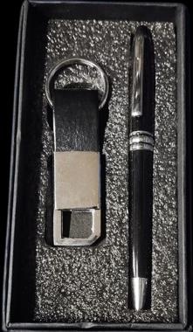  Black pen with small ring-tab keychain  Rs. 83/-  Base Rs. 70 + 18% GST |  | Item No. 31  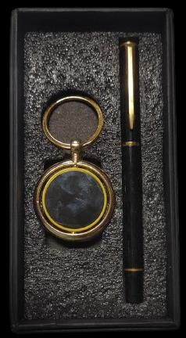  Bamboo pen with cork & leather keychain  Rs. 100/-  Base Rs. 85 + 18% GST
Item No. 32  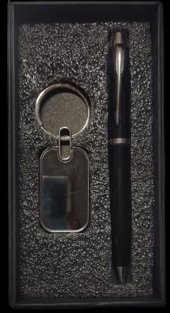  Two-tone pen with wooden rectangular keychain  Rs. 59/-  Base Rs. 50 + 18% GST |  | Item No. 33  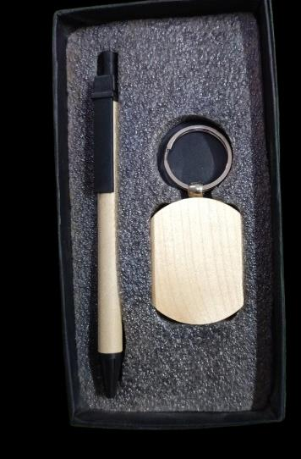  Black pen with wooden rectangular keychain  Rs. 59/-  Base Rs. 50 + 18% GST
Item No. 34  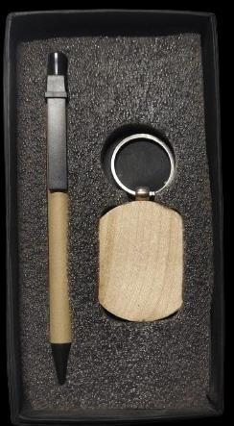  Black pen with tall wooden keychain  Rs. 89/-  Base Rs. 75 + 18% GST |  | Item No. 35  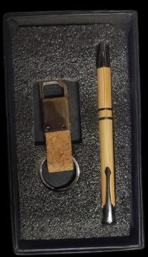  Black pen with cork & metal keychain  Rs. 106/-  Base Rs. 90 + 18% GST
Item No. 36  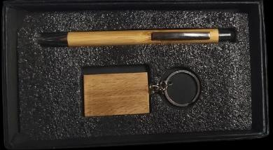  Blue pen with blue enamel oval keychain  Rs. 106/-  Base Rs. 90 + 18% GST |  | Item No. 37  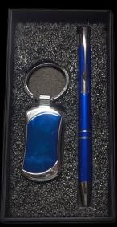  Red pen with red leather tab keychain  Rs. 106/-  Base Rs. 90 + 18% GST
Item No. 38  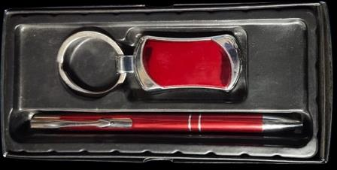  Red pen with red enamel keychain  Rs. 94/-  Base Rs. 80 + 18% GST |  | Item No. 39  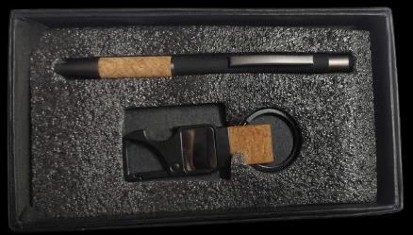  Roller pen with metal rectangular keychain  Rs. 100/-  Base Rs. 85 + 18% GST
Item No. 40  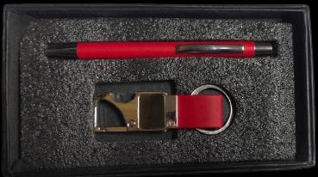  Silver pen with metal keychain, stand box  Rs. 77/-  Base Rs. 65 + 18% GST |  | Item No. 41  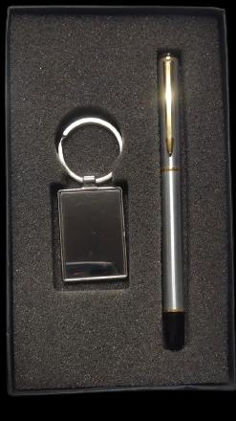  Rose-gold pen with tan leather keychain  Rs. 94/-  Base Rs. 80 + 18% GST
Item No. 42  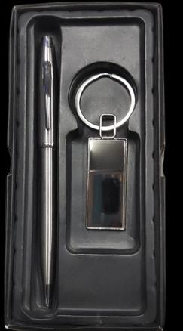  Slim black pen with teardrop keychain  Rs. 89/-  Base Rs. 75 + 18% GST |  | Item No. 43  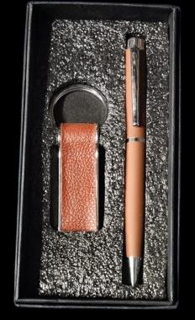  Gold pen with gold rectangular keychain  Rs. 124/-  Base Rs. 105 + 18% GST
Item No. 44

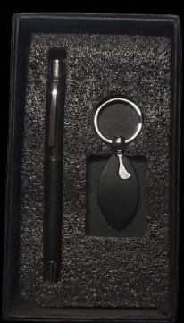

Gold pen with black leather & gold hook keychain

Rs. 124/-

Base Rs. 105 + 18% GST

Thank you
for considering Robust Gifting

All items available for custom branding.
Minimum order quantities and lead times on request.
Prices are exclusive of 18% GST. Valid 2026.

